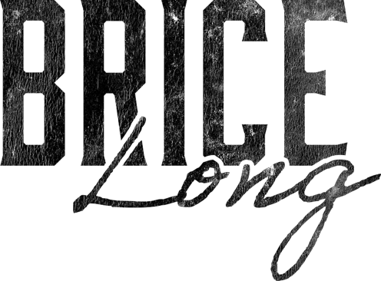

Brice has enjoyed a successful 25+ year music career. As a songwriter he has had over 200 of his songs cut with artists such as Garth Brooks, George Strait, Chris Stapleton, Hank Williams Jr, Randy Houser, Jon Pardi, Lainey Wilson, Gary Allan, Chris Young, Josh Turner, Cody Johnson, Reba McEntire,
Randy Travis, Randall King and many more.

Brice’s songwriting hits include the #1 singles “Heartache On The Dance Floor” by Jon Pardi and “Nothing On But The Radio” by Gary Allan. Randy Houser’s “Like a Cowboy”, a song that also garnered Brice a CMA nomination for Song of the Year. Other radio hits include Randy Houser’s debut single, “Anything Goes”, “Today” from Gary Allan, Casey James’ “Let’s Don’t Call It A Night” and Jon Pardi’s, “What I Can’t Put Down”.

In 2026 Brice Long turns the spotlight on himself with the release of a full-length album of his own. All I Ever Wanted To Be, marks a defining moment in his career as the storyteller steps forward to showcase his voice in an introspective project that captures the heart, grit, and storytelling of a true country craftsman.

Brice is signed to Sony Music Publishing. He is a native of Hopkinsville, KY.
His music is available wherever digital music is streamed and sold.

For more info:
bricelongmusic.com | Facebook | X | Instagram | TikTok | YouTube | Spotify

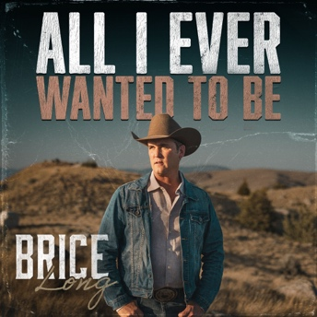

Listen to All I Ever Wanted To Be

